**Char Arry**

|  |
| --- |
| #include <iostream>  using namespace std;  int main()  {  char name[]= "I Like C";  int i=0;  while(name[i] != '\0'){      cout << name[i];  i++;  }    return 0;  } |

Output

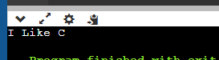

**Getting input from user**

|  |
| --- |
| #include <iostream>  using namespace std;  int main()  {  char name[5];  int i=0;  cout << "Enter the string ";  cin.getline(name,5);  while(name[i] != '\0'){  cout << name[i];  i++;  }  return 0;  } |

Output

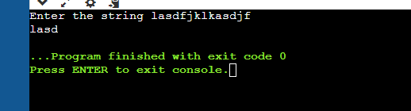

**How to concatenate the string or char arry**

|  |
| --- |
| #include <iostream>  #include <cstring>  using namespace std;  int main()  {  char name[10]= "Haseeb";  char name2[34]= "khan";    cout << strcat(name,name2);    return 0;  } |

Output

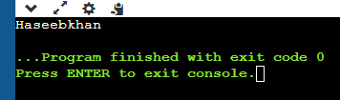

**Copy of string**

|  |
| --- |
| #include <iostream>  #include <cstring>  using namespace std;  int main()  {  char name[10]= "Haseeb";  char name2[34]= "khan";    cout << strcpy(name,name2)<<endl;    cout << strcat(name,name2)<<endl;  cout << name<<endl;  cout <<" asdasd"<<endl;  cout << name2<<endl;      cout << strcpy(name,name2);  cout << name<<endl;  cout << name2<<endl;        return 0;  } |

Output

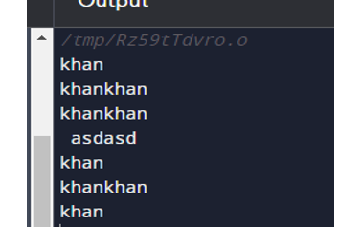

**Example 15.1:** Write a program that prints a string.

|  |
| --- |
| #include <iostream>  using namespace std;  int main()  {  char array[20];  cout<<"Enter a string: ";  cin.getline(array, 20);  cout<<"You entered the string: "<<array<<endl;  return 0;  } |

Output

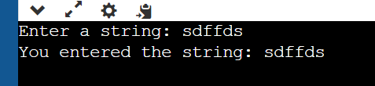

**Example 15.3:** Write a program that input a string. (Using get method)

|  |
| --- |
| #include <iostream>  using namespace std;  int main()  {  char str[10];  cout << "Enter a string: ";  cin.get(str, 10);  cout << "You entered: " << str << endl;  return 0;  } |

**Output**

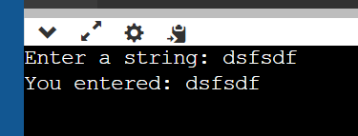

**Example 15.4:** Write a Program that Inputs a string using cin only.

|  |
| --- |
| #include <iostream>  using namespace std;  int main()  {  char array[20];    cout<<"Enter a string: ";  cin>>array;  cout<<"You entered the string: "<<array<<endl;  return 0;  } |

**Output**

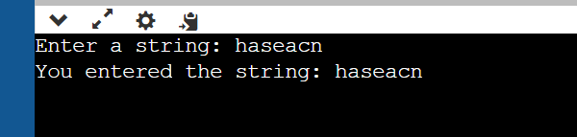

**Example 15.5:** Operations on Strings

|  |
| --- |
| #include <iostream>  #include <cstring>  using namespace std;  int main()  {  string names = "ggg ok ";  string names2 = "good a";          cout << names + names2<<endl;    names = names2;    cout << names;      return 0;  } |

**Output**

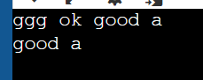

**Example 15.6:** Demonstation of Library functions.

|  |
| --- |
| #include <iostream>  #include <cstring>  using namespace std;  int main ()  {  char fff[555] = "gohkhsdfsdfdsj";  char ggg[10] = "Abbas";  char www[10];  int len ;  strcpy( www, fff);  cout << "strcpy( www, fff) : " << www << endl;  strcat( fff, ggg);  cout << "strcat( fff, ggg): " << fff << endl;  len = strlen(fff);  cout << "strlen(fff) : " << len << endl;  return 0;  } |

**Output**

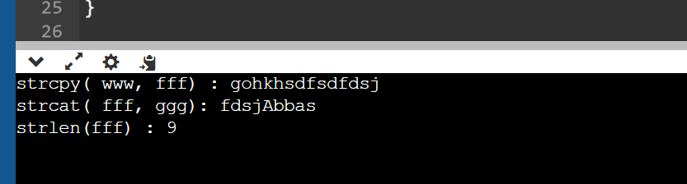

**Example 15.:** Write a program to compare two strings using *strcmp*. Also make use of *gets()* to read the string.

|  |
| --- |
| #include <iostream>  #include <cstring>  using namespace std;  int main () {  char a[100], b[100];  cout<<"Enter the first string: ";  cin.getline(a,100);  cout<<"Enter the second string: ";  cin.getline(b,100);  if (strcmp(a,b) == 0)  {  cout<<"Entered strings are equal.\n";  }else  {  cout<<"Entered strings are not equal.\n";  }  return 0;  } |

**Output**



**Example 15.8:** Write a program that prints string in reverse order.

|  |
| --- |
| #include <iostream>  #include <cstring>  using namespace std;  int main () {  char arr[100];  cout<<"Enter a string to reverse\n";  cin.getline(arr,100);  strrev(arr);  cout<<"Reverse of entered string is: "<<arr<<endl;  return 0;  } |

**Output**

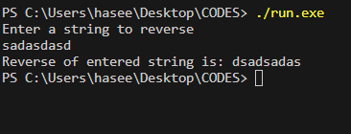

* 1. **Exercises for lab**

**Exercise 13.1** Write a program that reads a string and print the number of vowels letters.

|  |
| --- |
| #include <iostream>  #include <string>  using namespace std;  int main()  {  string name[4] = {  "haseeb",  "noman",  "oman",  "ashiq"  };  for (int i = 0; i < 4; i++)  {  if (name[i][0] == 'u' || name[i][0] == 'o' || name[i][0] == 'i' || name[i][0] == 'e' || name[i][0] == 'a')  {  cout << name[i] << " ";  }  }  return 0;  } |

**Output**

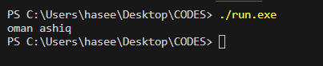

**Exercise 13.2** Write a Program number that reads a string and print upper case and number of lower case letters.

|  |
| --- |
| #include <iostream>  using namespace std;  int main()  {  string name[4]={  {"haSeeb"},  {"noman"},  {"Oman"},  {"Ashiq"}  };  for (int i = 0; i < 4; i++)  {  for (int j = 0; j < 20; j++)  {  if (name[i][j]>= 'A' && name[i][j] <= 'Z')  {  cout << name[i][j];  }  }  }  int count = 0;  for (int i = 0; i < 4; i++)  {  for (int j = 0; j < 20; j++)  {  if (name[i][j]>= 'a' && name[i][j] <= 'z')  {  count++;  }  }  }  cout << "\n"<<count;  return 0;  } |

**Output**

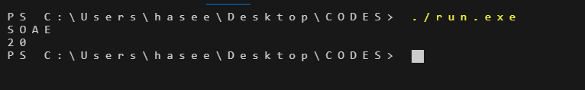

**Exercise 13.3** Write a program that reads a string and print the string with the first letter capitalized and the remaining in lower case.

|  |
| --- |
| #include <iostream>  #include <string>  using namespace std;  int main() {  string String = "where you are ";  iString[0] = toupper(String[0]);  for (size_t i = 1; i < String.length(); ++i) {  String[i] = tolower(String[i]);  }  cout << "new string: " << String << endl;    return 0;  } |

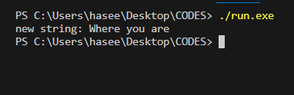

**Home Work**

* + 1. Write a program that reads a string and print the reverse of that string:

e.g. User Enter string: This is a cat

Output: - tac a si siht

|  |
| --- |
| #include <iostream>  #include <string>  #include <cstring>  using namespace std;  int main() {  char wtring[59] = "This is a cat";  strrev(wtring);  cout << wtring;  return 0;  } |

**Output**

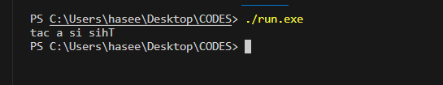

* + 1. Write a program that reads a string and print the string’s words in reverse order:

e.g. User Enter string: This is a cat

Output: - cat a is This

|  |
| --- |
| #include <iostream>  #include <string>  #include <cstring>  using namespace std;  int main() {      char wtring[8] = "This is";      char wtring2[6] = "a cat";        strcat(wtring2, wtring);      cout << wtring2;        return 0;  } |

**Output**

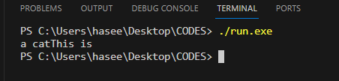

**Templates:**

|  |
| --- |
| #include <iostream>  using namespace std;  template <typename T> T graternumbers(T num1, T num2)  {  if (num1 < num2)  {  return num1;  }else{  return num2;  }  }  int main()  {  cout << "Enter the numbers: ";  int num1,num2;  cin >> num1 >> num2;  cout<< "output"<<endl;  cout << graternumbers<int>(num1,num2)<<endl;  cout << graternumbers<double>(num1,num2)<<endl;  cout << graternumbers<char>(num1,num2)<<endl;      return 0;  } |

**Output**

